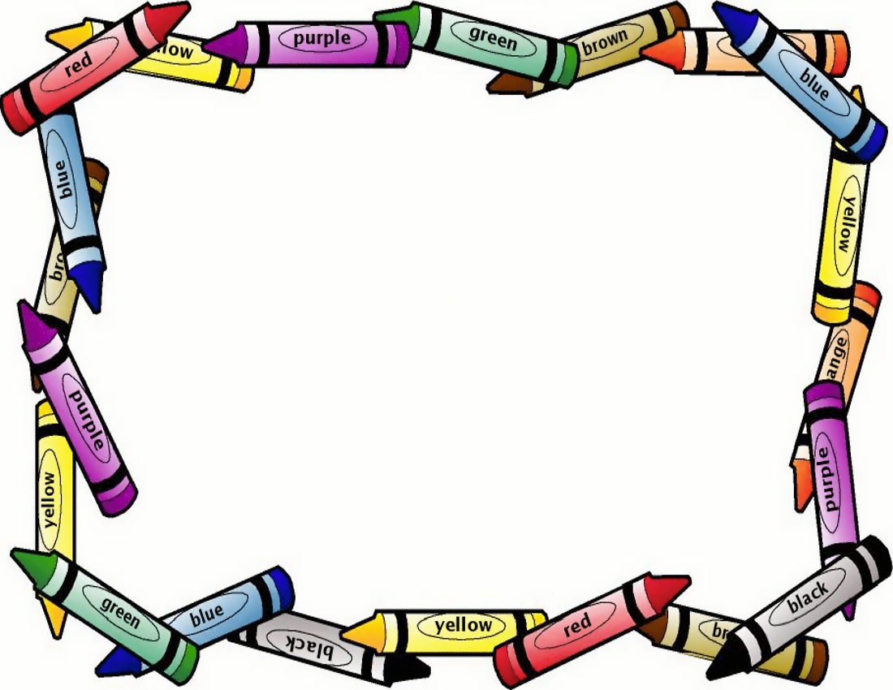

**Classroom Rules**

1. Listen
2. Raise your hand
3. Take turns
4. Share
5. Keep your hands to yourself
6. Be polite
7. Use kind words: (please, thank you, you are welcome)
8. Cover your mouth & nose when you cough or sneeze.